SEQUENCE DIAGRAMS
FOR
MindCare – Online Mental Health Support System
Software Engineering Assignment
Submitted To:
Kinza Sardar
Submitted By:
Abdul Rehman Shakir
Registration / Roll No:
F2024065027
Section:
W 8
Course:
Software Engineering
Department:
Department of Software Engineering
University:
University of Management and Technology (UMT), Lahore

Sequence Diagram 1: User Registration

Actors
- User (Patient)

Objects
- MindCare App
- Authentication Service
- Database
- Email Verification System

Flow
- The user enters registration details in the MindCare app.
- The app sends the details to the authentication service.
- The authentication service validates the information.
- User data is stored in the database.
- A verification email is sent through the email service.
- The user receives confirmation of successful registration.
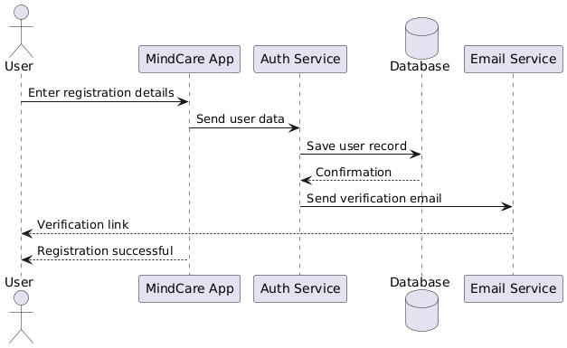

Sequence Diagram 2: User Login

Actors
- User

Objects
- MindCare App
- Authentication Service
- Database

Flow
- The user enters email and password.
- The app forwards credentials to the authentication service.
- The authentication service verifies credentials from the database.
- Login status is returned to the app.
- The user is redirected to the dashboard.

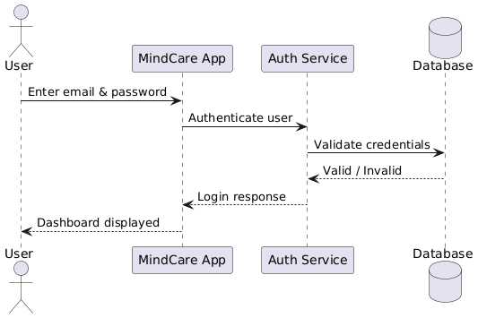

Sequence Diagram 3: Record Mood Journal

Actors
- User

Objects
- MindCare App
- AI Mood Analyzer
- Database

Flow
- The user starts a new mood journal entry.
- The user selects a mood and writes notes.
- The app sends the data to the AI analyzer.
- The AI analyzes emotional content.
- Mood data and analysis results are saved in the database.
- The system confirms successful entry.
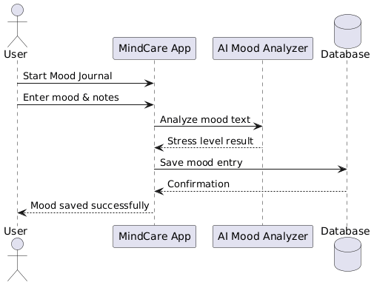

Sequence Diagram 4: Chat with Therapist

Actors
- User
- Therapist (Dr. Shakir)

Objects
- MindCare App
- Chat Server
- Database
- Notification Service

Flow
- The user sends a message via the chat interface.
- The app forwards the message to the chat server.
- The message is stored in the database.
- The therapist receives a notification.
- The therapist replies to the message.
- The reply is stored and delivered to the user.
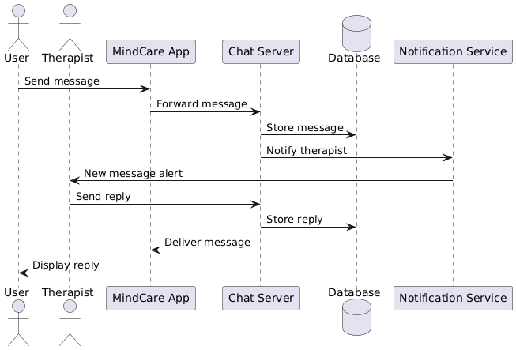
Sequence Diagram 5: Book Appointment

Actors
- User
- Therapist (Dr. Shakir)

Objects
- MindCare App
- Appointment Scheduler
- Database
- Notification Service

Flow
- The user selects a therapist and time slot.
- The app sends booking request to the scheduler.
- Availability is checked from the database.
- The appointment is saved.
- Notifications are sent to both user and therapist.
- The user receives booking confirmation.

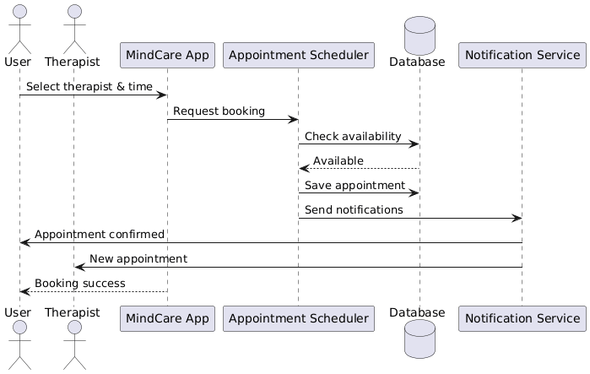
Sequence Diagram 6: AI Stress Detection

Actors
- (System-triggered – no direct human actor)

Objects
- MindCare App
- AI Mood Analyzer
- Database

Flow
- The system detects new mood or text input.
- The data is sent to the AI analyzer.
- Stress level is calculated.
- Results are stored in the database.
- Recommendations are shown to the user.

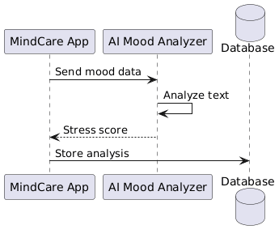

Sequence Diagram 7: View Resources

Actors
- User

Objects
- MindCare App
- Database

Flow
- The user opens the Resources section.
- The app requests available content from the database.
- Articles and videos are retrieved.
- The content is displayed to the user.

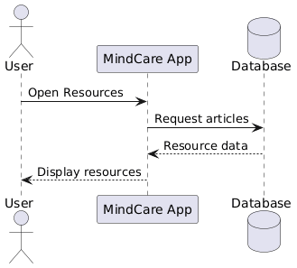

Complete Sequence Diagram – MindCare Project

Actors & Components Used

Actors
- User (Patient): Initiates all major system interactions such as registration, login, mood journaling, chatting, and booking appointments.
- Therapist (Dr. Shakir): Provides mental health support through chat and scheduled sessions.

System Components
- MindCare App: Front-end interface through which users interact with the system.
- Authentication Service: Handles user registration, login, and credential validation.
- AI Mood Analyzer: Analyzes user mood entries and detects stress levels.
- Chat Server: Manages real-time messaging between users and therapists.
- Appointment Scheduler: Handles appointment booking and availability management.
- Database: Stores user data, mood journals, chat history, and appointment records.
- Notification Service: Sends alerts and reminders to users and therapists.
- Email Service: Sends account verification and password recovery emails.

Overall Flow of the Complete Sequence Diagram
- The user starts by registering an account through the MindCare application.
- The authentication service validates the registration details and stores user data in the database.
- A verification email is sent to the user via the email service.
- After verification, the user logs into the system using valid credentials.
- Once logged in, the user records mood journal entries.
- The mood data is sent to the AI mood analyzer, which evaluates emotional patterns and determines stress levels.
- The analyzed results are stored in the database and displayed to the user.
- The user initiates a chat session with the therapist (Dr. Shakir).
- Messages are routed through the chat server and stored in the database.
- The therapist receives notifications for new messages and responds accordingly.
- The user may then book an appointment with the therapist.
- The appointment scheduler checks availability and confirms the booking.
- Notifications are sent to both the user and therapist regarding the scheduled session.
- The user can also access mental health resources such as articles and exercises.
- Resource content is fetched from the database and displayed to the user.

